|  |  |
| --- | --- |
| **­­­Exp No: 1**  **Date: 7.2.25** | **HTML AND CSS** |

**AIM:**

To create a web page that embeds a map with hotspots, frames, and links using embedded, external, and inline CSS

**PROGRAM:**

**Hotspot.html**

<!DOCTYPE html>

<html>

<head>

<title>Hotspot</title>

<link rel=*"stylesheet"* type=*"text/css"* href=*"style.css"*>

<style>

**h1** {

text-align: *center*;

color: *#333*;

margin-top: *20px*;

}

</style>

</head>

<body>

<!-- Inline style for the image itself (optional to override or enhance external styles) -->

<h1>Interactive Map of India</h1>

<img src=*"https://lh3.googleusercontent.com/drive-storage/AJQWtBMbgk1vnoLjbqNzqQENJ9m0yqgJjG4t7bQQFUxI52QlRDDk2Ab-LjgmmDOq-Fs1lcIWsSO6gcYaK8nkw9OaEe1OuR-29RF2I8xTlmKxYswWex0=w1905-h911"* usemap=*"#indiamap"* width=*"900"* height=*"720"* alt=*"Map of India"*>

<map name=*"indiamap"*>

<area shape=*"rect"* coords=*"324,578,407,535"* alt=*"Tamil Nadu"* href=*"https://en.wikipedia.org/wiki/Tamil_Nadu"*>

<area shape=*"rect"* coords=*"343,655,398,599"* alt=*"Tamil Nadu"* href=*"https://en.wikipedia.org/wiki/Tamil_Nadu"*>

<area shape=*"rect"* coords=*"407,538,395,602"* alt=*"Tamil Nadu"* href=*"https://en.wikipedia.org/wiki/Tamil_Nadu"*>

<area shape=*"rect"* coords=*"346,653,397,605"* alt=*"Tamil Nadu"* href=*"https://en.wikipedia.org/wiki/Tamil_Nadu"*>

<area shape=*"rect"* coords=*"406,537,324,579"* alt=*"Tamil Nadu"* href=*"https://en.wikipedia.org/wiki/Tamil_Nadu"*>

</map>

</body>

</html>

**Style.css**

@charset *"ISO-8859-1"*;

**body** {

font-family: *Arial,* *sans-serif*;

margin: *0*;

padding: *0*;

background-color: *#f4f4f4*;

}

**img** {

display: *block*;

margin: *0* *auto*;

border-radius: *8px*;

box-shadow: *0* *4px* *6px* *rgba(0,* *0,* *0,* *0.1)*;

}

/* Styling for the map areas */

**area** {

outline: *none*;

border: *none*;

transition: *transform* *0.3s* *ease-in-out*;

}

**area***:hover* {

transform: *scale(1.1)*;

}

**OUTPUT:**

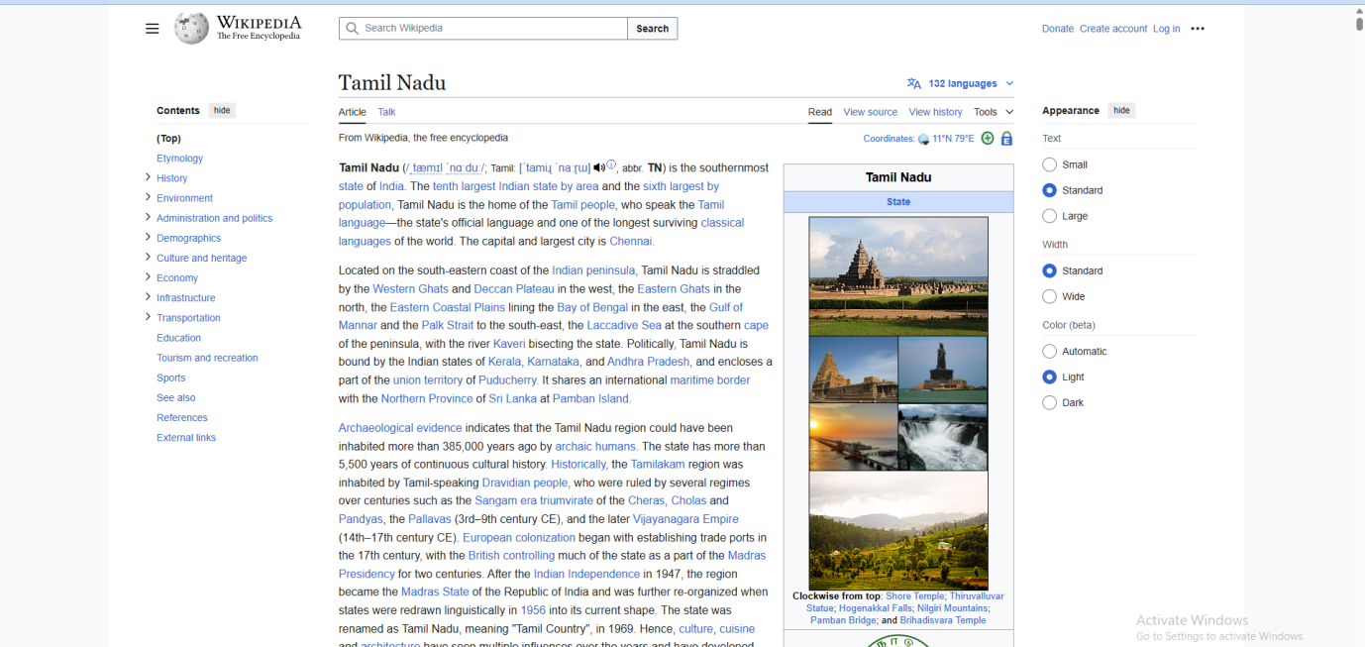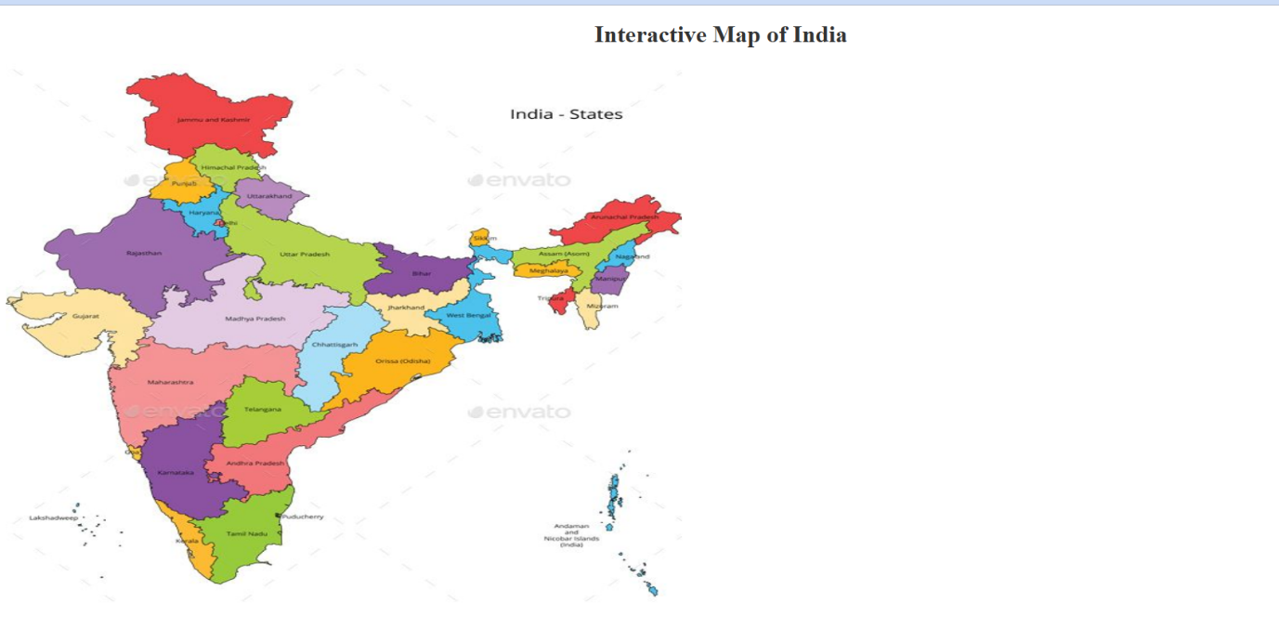

**RESULT :**Thus the experiment to create a web page that embeds a map with hotspots, frames, and links using embedded, external, and inline CSS has been successfully implemented and verified .